Software Abstraction Layer

by Danut Prisacaru

Summary: The N-tier architecture has been with us for many years. It had helped us separate the Presentation Tier from the Business Tier and that in turn from the Data Tier. This provides a higher degree of decoupling when compared to the old 1 or 2-tier architecture. While the N-tier architecture is helping us make the applications more flexible and easier to change there is still an important potential for coupling between the different technologies and logical layers that exist in each physical tier.
This article tries to identify the points of coupling and also propose a solution that will increase the separation of concerns. This will allow the N-tier applications to be easier to change. While the article is using the .NET technologies and the C# language to make the point, the solutions can apply to other platforms and languages as well.
We will also provide a proof of concept prototype that will illustrate the points we are trying to make in this article.
Contents

Scenario
For the purpose of this article we will imagine an application that uses the 3-tier architecture. The Presentation Tier is implemented using Win Forms, the Middle Tier is using IIS and it exposes web services and the Data Tier will be provided by SQL Server.
A simplified view of the 3-tier architecture will look like Figure 1.

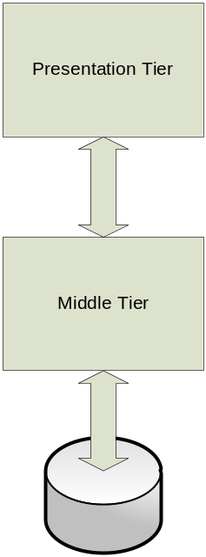
Figure 1. The classic 3-tier Architecture
Looking deeper at what happens in each physical tier we may discover that each of them is a mix of several logical layers and in many cases these layers depend on each other.
The complexity of mixing code
If we zoom in into the Presentation Tier and the Middle Tier we will discover that they are not monolithic and homogenous modules. Each tier is actually made of several logical layers. For example the Presentation Tier has a UI part and also a logical layer composed of proxies that help the UI talk to the Middle Tier. This tier is also composed of the layer that talks to the DB, for example ADO.NET, the business logic modules and the layer that makes the service provider. A zoom in can look like Figure 2.
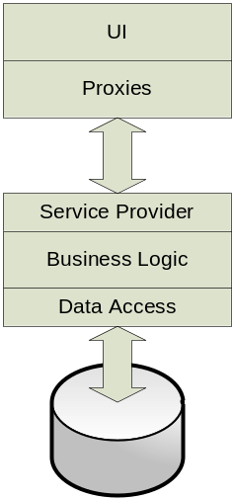
Figure 2. A zoom-in into each tier
In the ideal situation each logical layer is separated from the others. In reality many applications have a mix and match between them and the zoom-in model will look more like Figure 3.
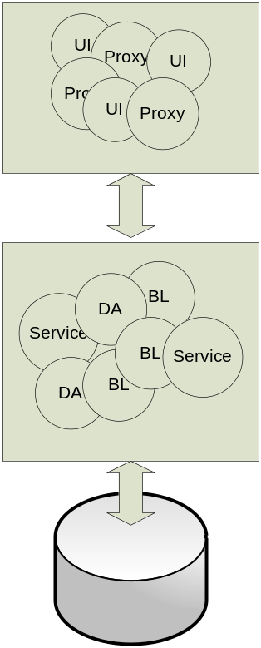
Figure 3. This is how many applications look in reality
When it happens, we loose all the benefits of separating the application into tiers. While the Presentation Tier is physically or logically separated from the Middle Tier, the mix and match between UI code and the proxies will make the code hard and costly to maintain. The same happens in the Middle Tier where we see the Service Provider (Service), the Business Logic (BL) and the Data Access (DA) interconnected with each others. It will be virtually impossible to replace one logical layer with a new technology.
Let’s say we currently use .NET 2.0 web services on the middle tier. On the Presentation Tier we had the proxies/references generated by Visual Studio. We plan to move to WCF. How are we going to do that if the implementation looks like Figure 3?
We all know that it is easy to build a new application from scratch. The most expensive part thought is to maintain it and if the architecture and design of the modules that make the application do not consider the cost of maintenance then transition to new technologies will be very expensive, in some cases it will require the total rewrite of the application. How do we build an application so we reduce the cost of the maintenance?
We also know that the complexity of any software system grows over time. How do we make it so, although the complexity grows, the parts that make the system stay simple and can be easily changed or even replaced?
N Tier Flexibility Relies on Layers
Potentially the business may require one day that the N from the “N Tier” to vary, say from 3 to 2 or other number.
We need a solution that can easily accommodate the business requirements like in Figure 4.
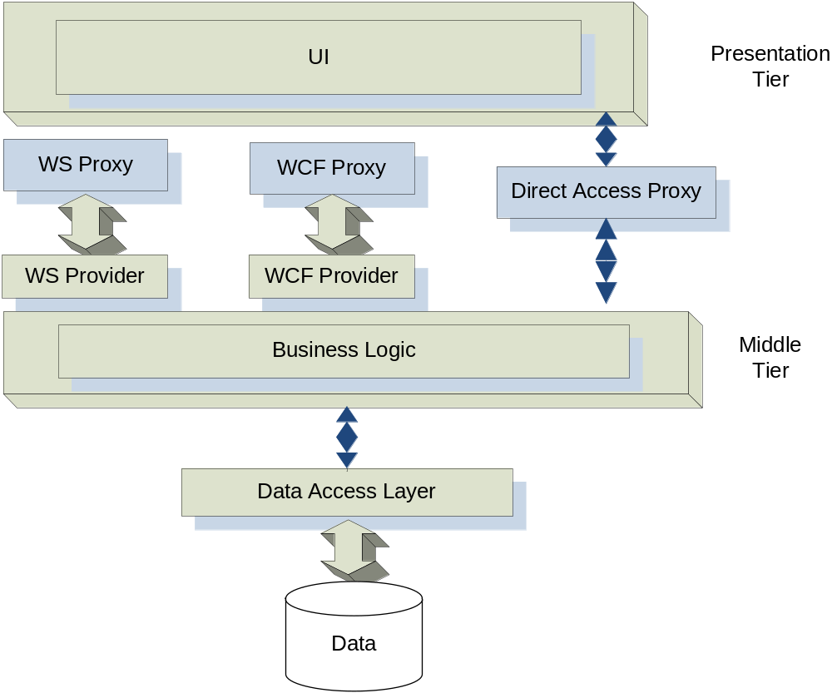
Figure 4. Flexible Architecture allows N to change from 3 to 2
Moving towards a better solution
Since we identified that each of the Presentation and Middle tiers are composed from several logical layers we can now try to find a solution that will keep the layers apart from each other.
What we know so far:
- We need to avoid mixing and matching code from different technologies or bringing code from one layer into another layer. We can do that by abstracting the interfaces between layers making them unaware of each other’s specifics.
- The layers need to exchange data and this data is the only thing they need to know about each other.
We will start by building a Data Container/Encapsulation Layer (DC/AL) that has only data types/classes generic enough to go trough different layers without affecting the decoupling.
The DC/AL must only contained primitive .NET types, types from System.Data (e.g. DataSet) or user defined types that can only contain the above types or other user defined types obeying these rules.
Abstraction in the Presentation Tier
Question: How can we make the UI layer unaware of the transport type and minimize the changes we need to make to replace a communication layer with another?
Answer: We design and code by interface and use factories to create the concrete classes. The UI will only “speaks” the “interfaces language”.
Pros and Cons of the Proposed Solution
Pros: Abstracting the communication between tiers provides a system easier to change in the future, the changes can be required by the business or they can come as a need to replace an old technology with a newer and better one. We can build a “Lego-like” software system that can evolve easier than old monolithically applications.
Cons: The initial setup requires more work but that is the same as any approach like CAB, SCSF or Acropolis. It requires some training and discipline from all the developers. It may requires code review once in a while to ensure that no one takes short cuts and accesses one layer from another by bypassing the Abstract Layer.
First attempt: Factory Method
We try to use the Factory Method pattern to implement the separation between the creation of the concrete classes and the caller.
Factory Method - Intent: Define an interface for creating an object, but let subclasses decide which class to instantiate. Factory Method lets a class defer instantiation to subclasses. (Source: Design Patterns by Erich Gamma, Richard Helm, Ralph Johnson and John Vlissides)
The code will look like this:

public class SALFactoryMethod
{
public enum CommunicationMethod
{
WS,
WCF,
DirectAccess
}
public static IAccountSettings GetAccountSettings(
CommunicationMethod comMethod )
{
if( CommunicationMethod.WS == comMethod )
return new WSAccountSettings();
else if( CommunicationMethod.WCF == comMethod )
return new WCFAccountSettings();
else if( CommunicationMethod.DirectAccess == comMethod )
return new DirectAccessAccountSettings();
}
}

Figure 5. Using the Factory Method

IAccountSettings accSettings = SALFactoryMethod.GetAccountSettings(
SALFactoryMethod.CommunicationMethod.WS);
Figure 6. The client code
Cons: We need to pass the Communication Method Type each time we need to create an object. This breaks the rule of the Open-Closed Principle (described first by Bertrand Meyer): “a good design has to assure that the implementation is closed to modification (in ways that affects clients) but open for extension (adaptable)”.
A Better Way: Abstract Factory
Abstract Factory - Intent: Provide an interface for creating families of related or dependent objects without specifying their concrete classes. (Source: Design Patterns by Erich Gamma, Richard Helm, Ralph Johnson and John Vlissides)

public abstract class GeneralWrapperFactory
{
protected GeneralWrapperFactory() { }
public static GeneralWrapperFactory Instance = null;
public abstract IWrapperAccountInformation
GetWrapperAccountInformation();

Figure 6. Abstract Factory –Base Class (also a Singleton)

public class WSWrapperFactory : GeneralWrapperFactory
{
public override IWrapperAccountInformation
GetWrapperAccountInformation();
{
return new WSWrapperAccountInformation();
}

Figure 6. Abstract Factory – the Concrete Class (WSWrapper)

* For WS
GeneralWrapperFactory.Instance = new WSWrapperFactory()

* For WCF
GeneralWrapperFactory.Instance = new WCFWrapperFactory()

Figure 7. Abstract Factory – Initializing the Singleton

IWrapperAccountInfomation accInfo =
GeneralWrapperFactory.Instance.GetWrapperAccountInformation();
Figure 7. Abstract Factory – The Client Code

Note: the client code is unaware of any kind of underlying technology used, no Web Services, no WCF and no ADO.NET specific code here!!!
Rules for building each tier/layer
1. Data Containers Layer (DCL)
  - It contains classes for data exchange between layers. Example AccountID, AccountConfigurationInfo and other classes that are now in the CyberTrader.Common.Tools.DataContainer namespace.
  - These classes only depend on .NET primitive types (Int32, String, etc) or other types/classes from this layer.
  - These classes must not depend on UI, WS, ADO.NET and other layers.
2. Data Wrappers (DW)
  - It contains classes that encapsulate the ADO.NET calls.
  - These classes must not depend on UI, WS, ADO.NET or other layers except ADO.NET.
3. Abstract Communication Layer (ACL)
  - It contains an abstract layer and an abstract factory which may have to be part of a separate assembly/library.
  - It depends on types defined by DCL and .NET types (Int32, String, etc).
  - These classes must not depend on UI, WS, ADO.NET or other layers.
  - These classes will be sub classed (inherited) by concrete layers. We could have 3 separate sub layers depending on the communication type
    - 3.a. Web Services
    - 3.b. WCF
    - 3.c. Data Access
4. Communication Layer (Consumer/Proxy/Reference) - Client Side (CLCS)
  - It depends on DCL (Data Containers Layer) and ACL (Abstract Communication Layer) and it also depends on the communication specific types, for example if the layer uses WS then it will depend on WS specific types and proxies.
5. Communication Layer (Provider) - Server Side
  - It contains the server side communication classes and types. For example if web services are used then the provider has web service definition classes (i.e. asmx files).
  - It does not call the DW directly, instead it calls the Communication Layer (3.c.) that subclasses the ACL and calls the database through DW.
  - These classes must not depend on UI or ADO.NET
The Data Containers and the Abstract Factory need to be very stable because almost all the components involved will use them therefore the coupling with these two will be high.
That is why one has to be very careful when choosing the types that make the data containers module. The same holds true for the interfaces exposed by the abstract factory.
The proposed solution offers the following advantages:
- Decreases the complexity and the coupling between modules. This leads to a more efficiency during the maintenance of the code.
- Eases the transition to new technologies: Ws to WCF, Win Forms to WPF, and ADO.NET to LINQ.
- Forces the developer to create reusable components instead of monolithic applications.
- Allows for independent testing. Because we separate the logical layers and provide a high degree of decoupling each logical layer/module can be tested independently or reused by other applications.
- Opens the door for dynamic loading of modules which we will address in a future article.
The modules dependency diagram is presented in Figure 8.
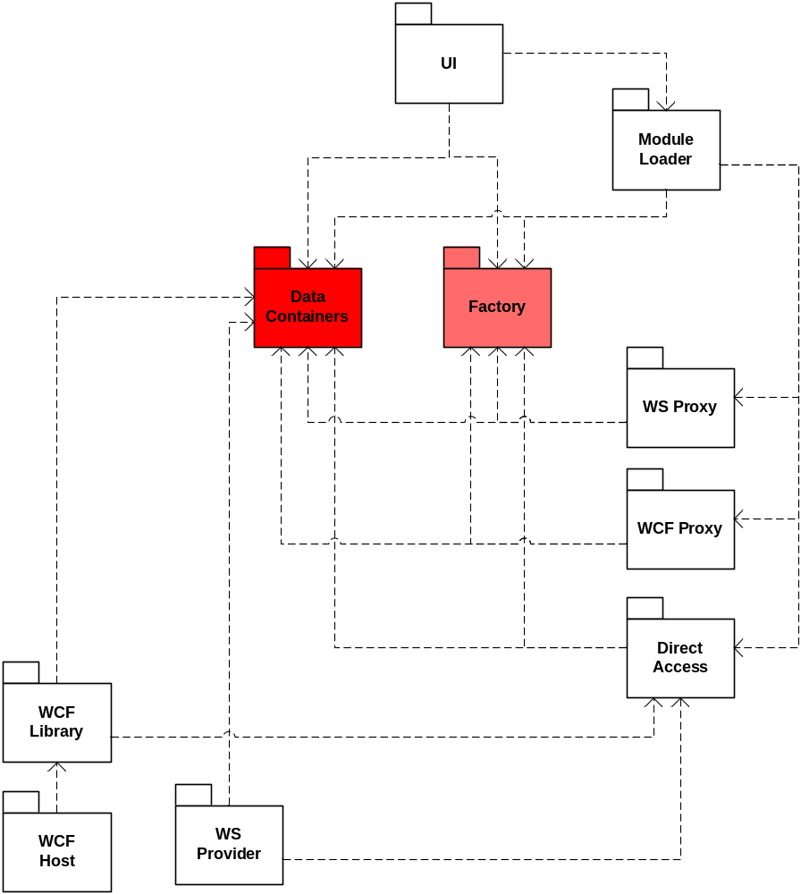
Figure 8. Modules Dependency Diagram
As we can see in the Figure 8 the UI does not depend anymore on the proxies/references, and neither depends on the direct access layer.
On the same time the Data Containers and the Factory modules have a high degree of coupling because almost all the other modules depend on them. The Data Containers contains only data and no code, the Factory contains only interfaces and abstract classes.
These two modules need to be very stable. Since many other modules depend on them, any change in these two modules may require expensive changes in many places, therefore a good solution is to adopt an old COM practice: once published an interface (and a Data Containers type) does not change/modify, if new features are required then we create new interfaces, add new types or add data members to the existing types. This way old code that is already using these two modules does not have to change and it can coexist with new client code that requires the new features.
The solution presented here was implemented in a real 3-tier application that has over 50,000 lines of code. While we did not plan to have it easily become a 2-tier since the beginning, we performed the exercised of trying to make it a 2-tier and we discovered that it was a job that took less than 4 hours. The exercise also showed other points of coupling we did not cover in our solution, i.e. static initializations performed when the ASP.NET Web Services application is starting.
Proof-of-concept Prototype
We provide a proof of concept prototype that shows the points we made in this article. The simple application has a Win Forms UI that can connect to the same data source in three different ways: by using Web Services, by using WCF or by direct connection. This change happens at run time by one line of code that just sets the concrete factory in each case.
The prototype can be found here on the www.coplex.com/sal web site.
About the Author
Danut Prisacaru is an Application Architect working in the financial industry. He has over 17 years of experience in developing Software Applications. In the last few years he architected, designed and implemented several 2 and 3-tier applications using Object Oriented Design principles, .NET, SQL Server, Smart Client and SOA. Danut likes to find solutions that can make an application easy to maintain. He likes the world of Object Oriented and he is also passionate about taking the business needs, analyze them and turn them into solutions that can improve the efficiency of the software applications. Danut can be contacted at danut@computer.org

